43.69: For deuterium:
a) 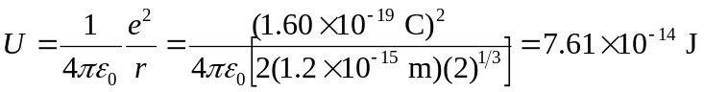
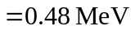
b) 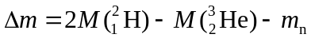
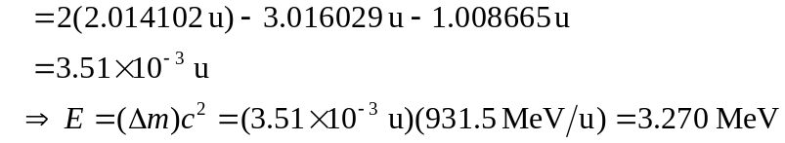
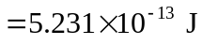
c) A mole of deuterium has 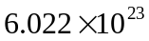 molecules, so the energy per mole is This is over a million times more than the heat of combustion.

